## **Part 1- Final Project Report**

* **Data Staging for New York (Talend ETL Job):**

1. **Job NYC_MVC_Staging-**

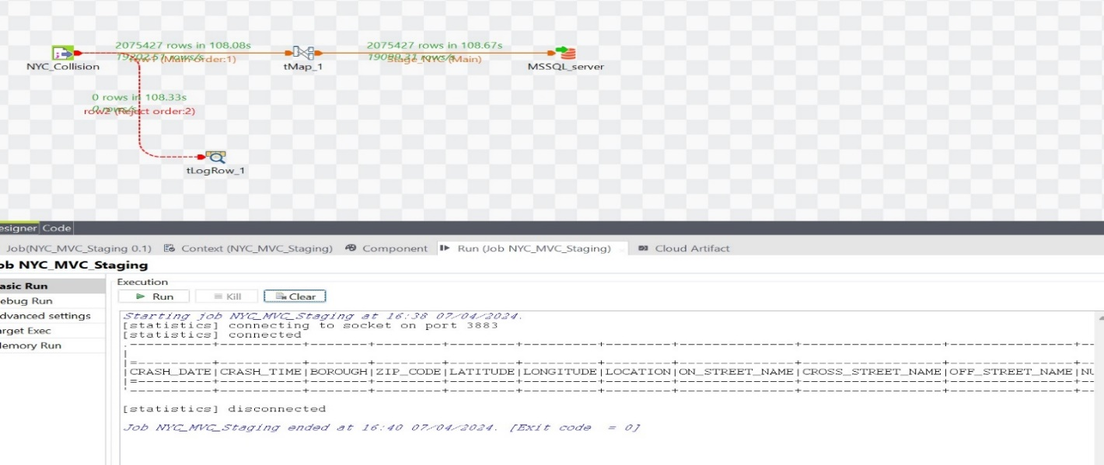

**COUNT:-**

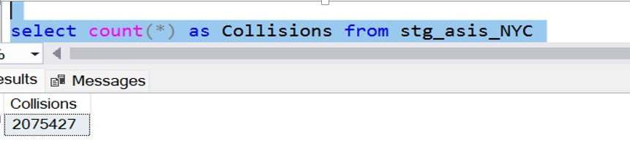

1. **Job NYC_MVC_Cleaned_Stg-**

**COUNT:-**

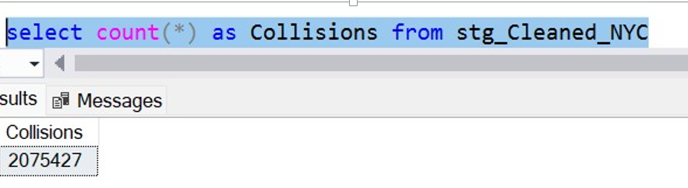

1. **Job NYC_Final_Staging-**

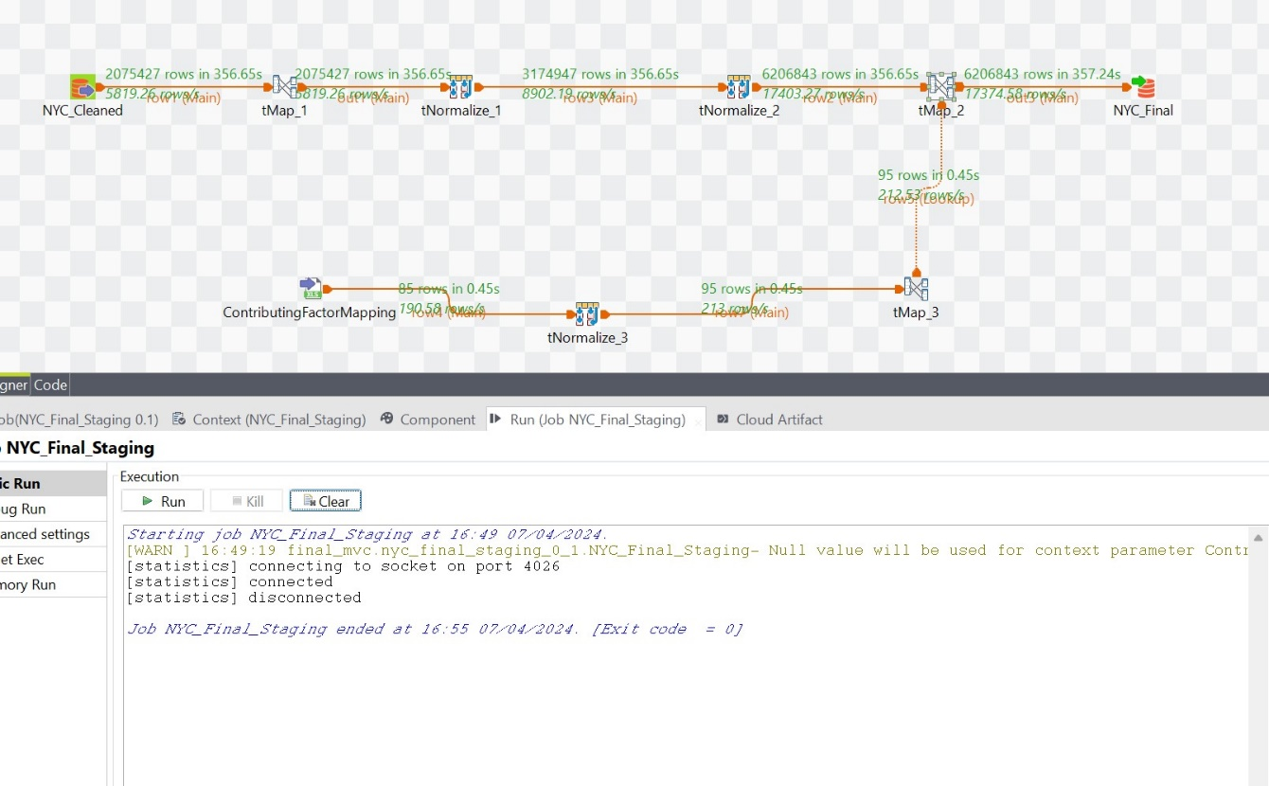

**COUNT:-**

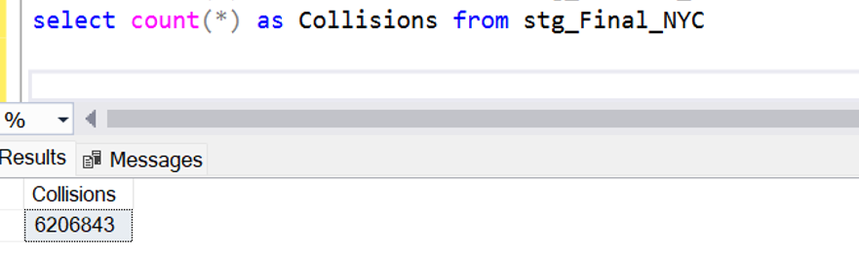

* **Stage Table Loading for NYC:-**

Select TOP 1000 * from stg_asis_NYC;

Select TOP 1000 * from stg_Cleaned_NYC;

Select TOP 1000 * from stg_Final_NYC;

* **Data Staging for Chicago (Talend ETL Job):-**

1. **Job Chicago_MVC_Staging-**

**Count:-**

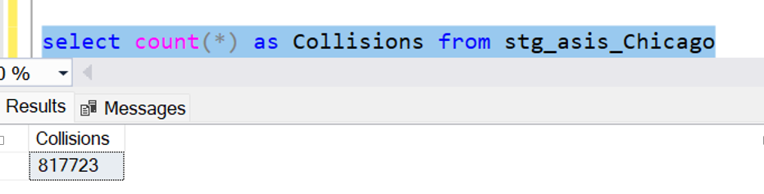

1. **Job Chicago_Cleaned_Staging-**

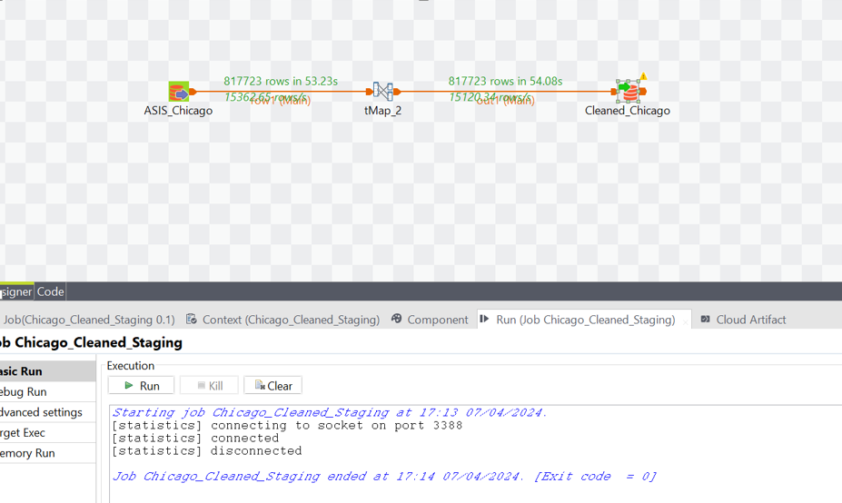

**Count:-**

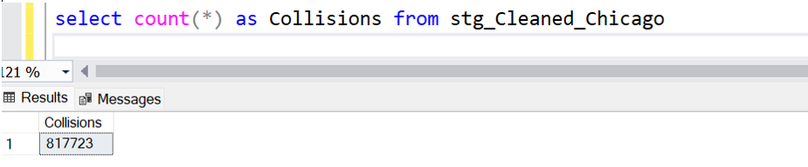

1. **Job Chicago_Final_Staging-**

**Count:-**

* **Stage Table Loading for Chicago:-**

Select TOP 1000 * from stg_asis_Chicago;

Select TOP 1000 * from stg_Cleaned_Chicago;

Select TOP 1000 * from stg_Final_Chicago;

* **Data Staging for Austin (Talend ETL Job):**

1. **Job Austin_MVC_Staging-**

1. **Job Austin_Final_Staging-**

1. **Job Austin_MVC_Cleaned_Staging-**

**Counts:-**

* **Stage Table Loading for Austin:-**

Select TOP 1000 * from stg_asis_Austin;

Select TOP 1000 * from stg_Cleaned_Austin;

Select TOP 1000 * from stg_Final_Austin;

**Dimensional model-Part 1**

